V5.10 IMMO IV IMMO IV+MQB and MQB key programming procedure

Go to Advanced Mode
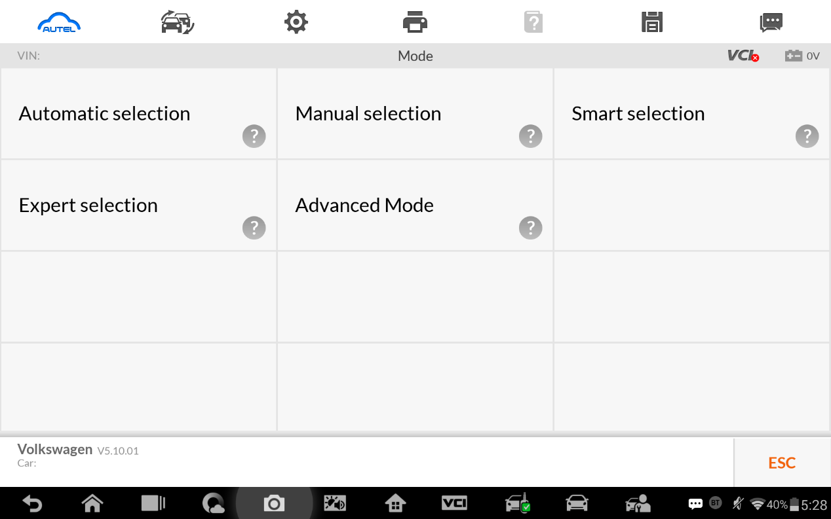

- MQB
Add key and all key lost two menus as follows:
Advanced Mode>MQB(Beta)>Key learning
Advanced Mode>MQB(Beta)>All keys lost
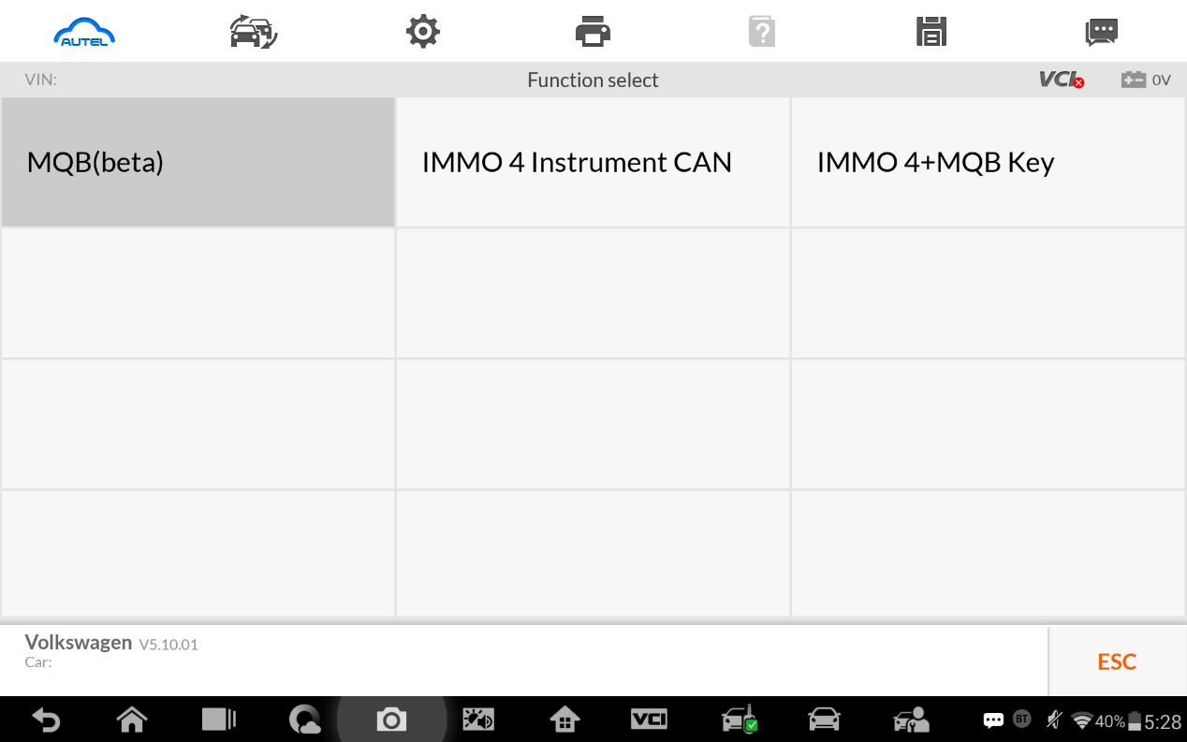

- IMMO IV
- Add key and all key lost two menus as follows:
Advanced Mode>IMMO 4 Instrument CAN>Key learning
Advanced Mode>IMMO 4 Instrument CAN>All keys lost
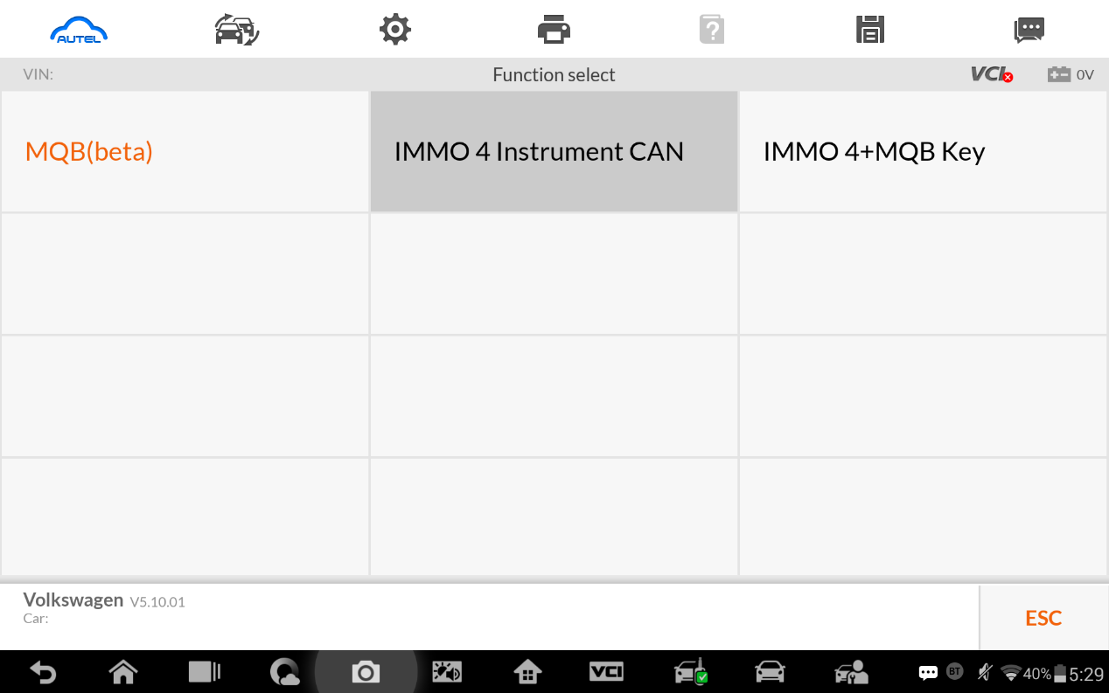
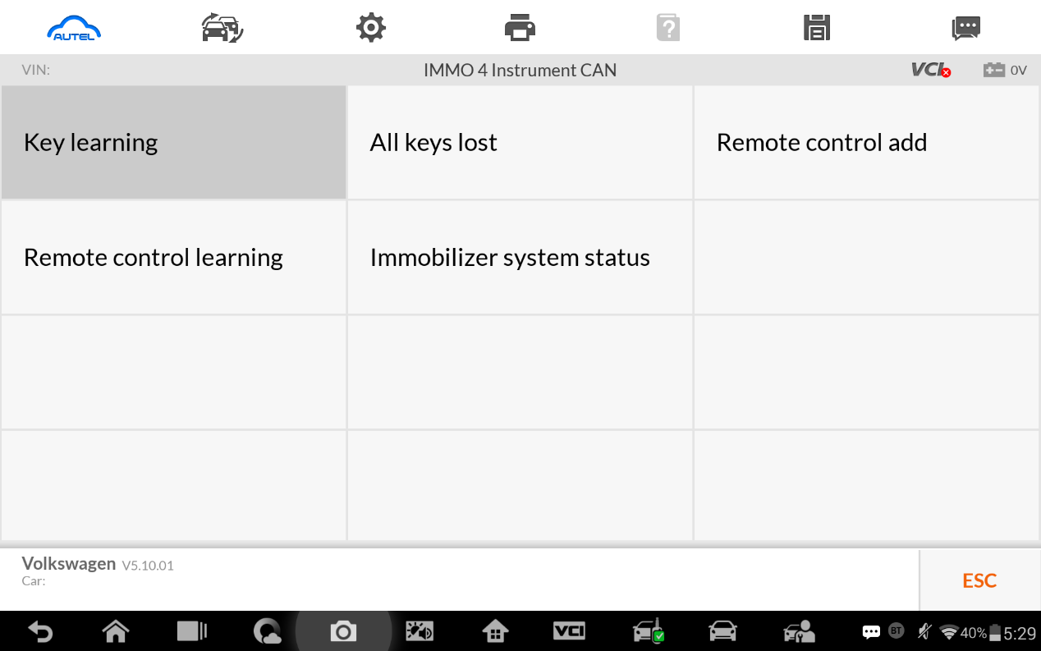

- IMMO IV+MQB
- Add key and all key lost two menus as follows:
Advanced Mode>IMMO 4 Instrument CAN>Key learning
Advanced Mode>IMMO 4 Instrument CAN>All keys lost

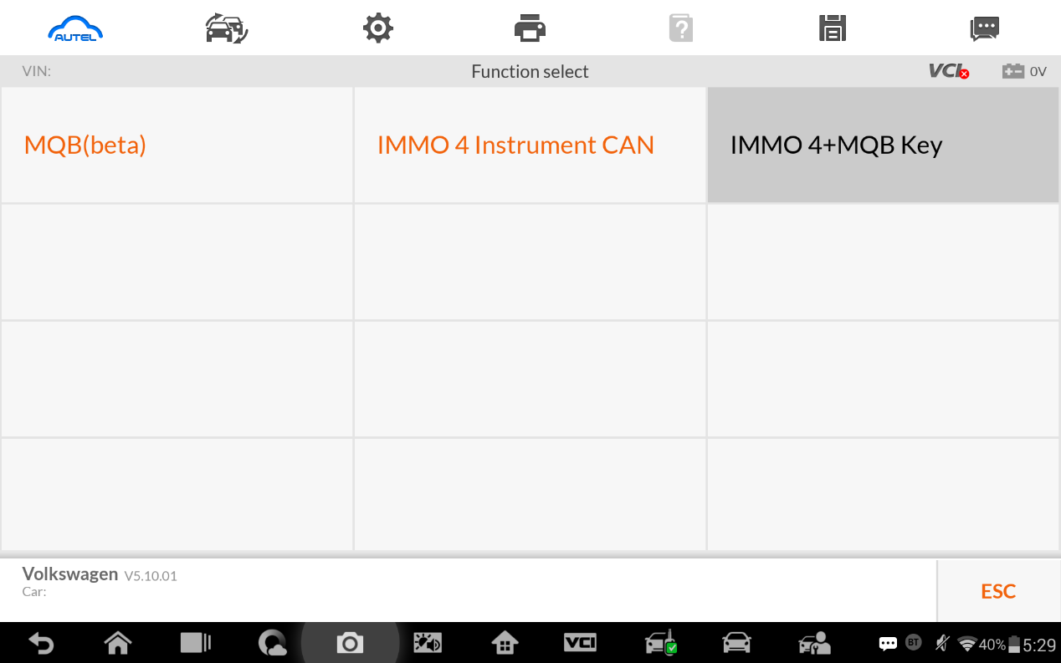
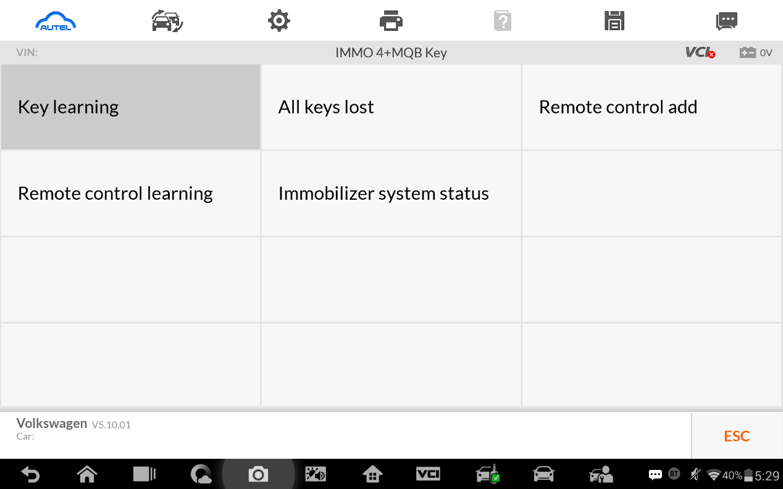

- IMMO data computation request interface.
Sever computation failed. Please contact the dealer!
Error code:1001
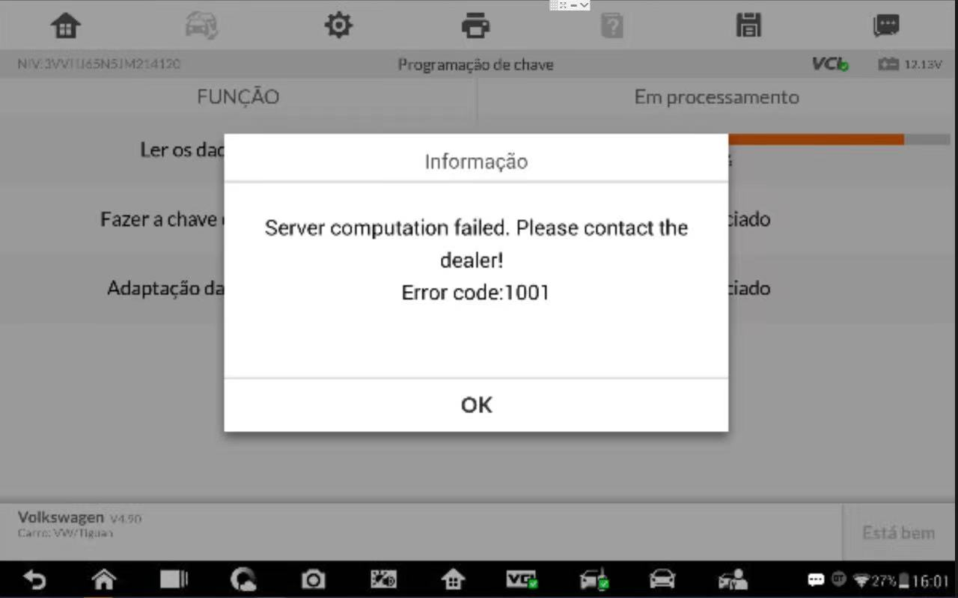

- Manually input pincode and cs code to do the key learning.
- IMMO IV
Make dealer key
Expert Selection>IMMO IV Instrument CAN>VDO NEC 24C64 2014>Make dealer key
Key learning:
Expert Selection>IMMO IV Instrument CAN>VDO NEC 24C64 2014>Key learning

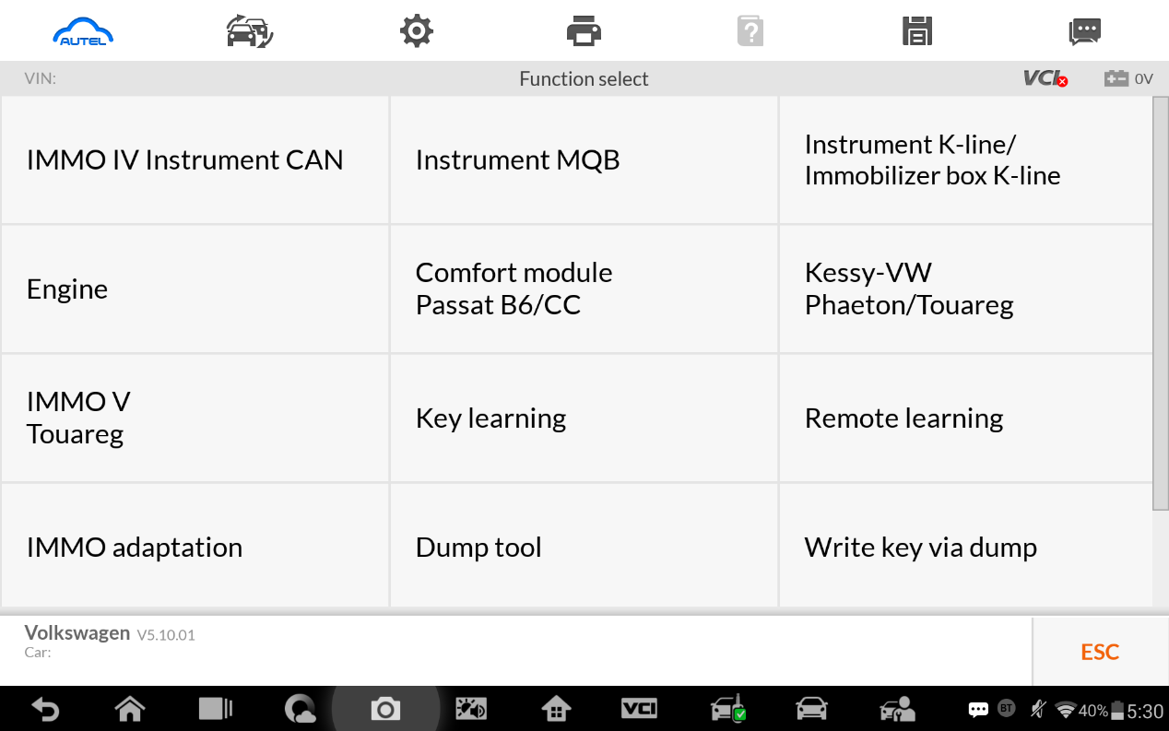

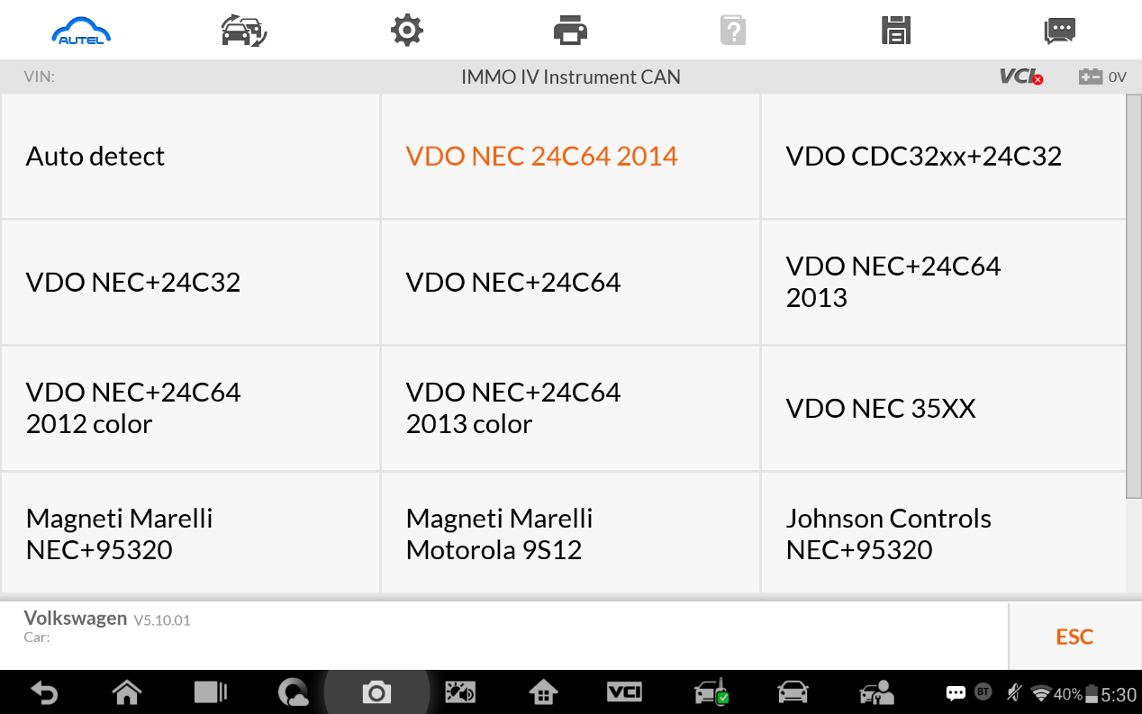
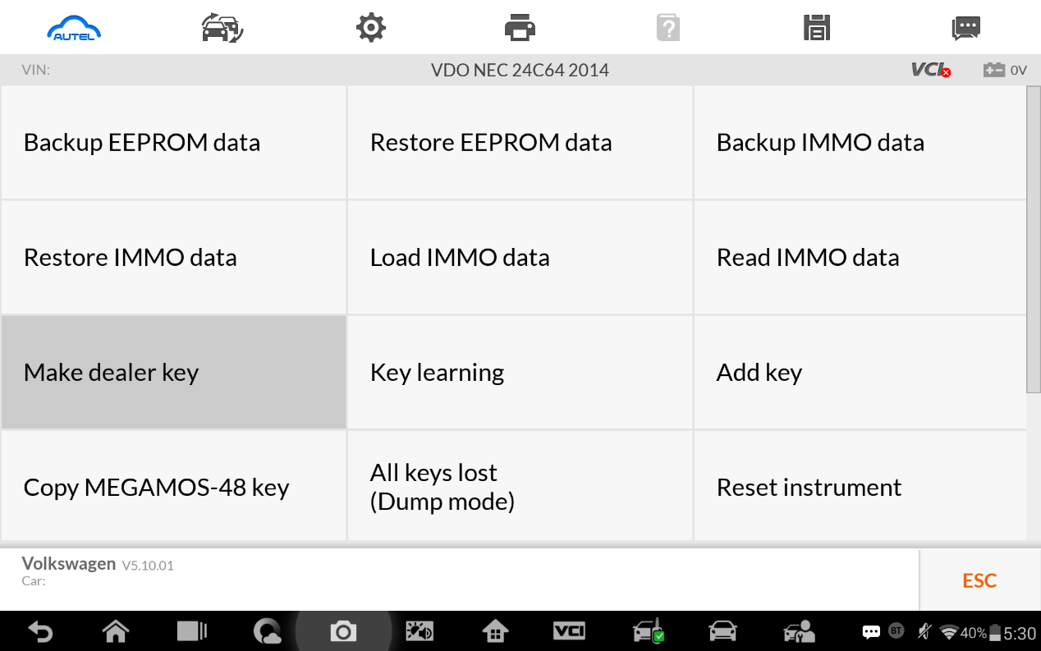

Make dealer key 输入Cs码界面
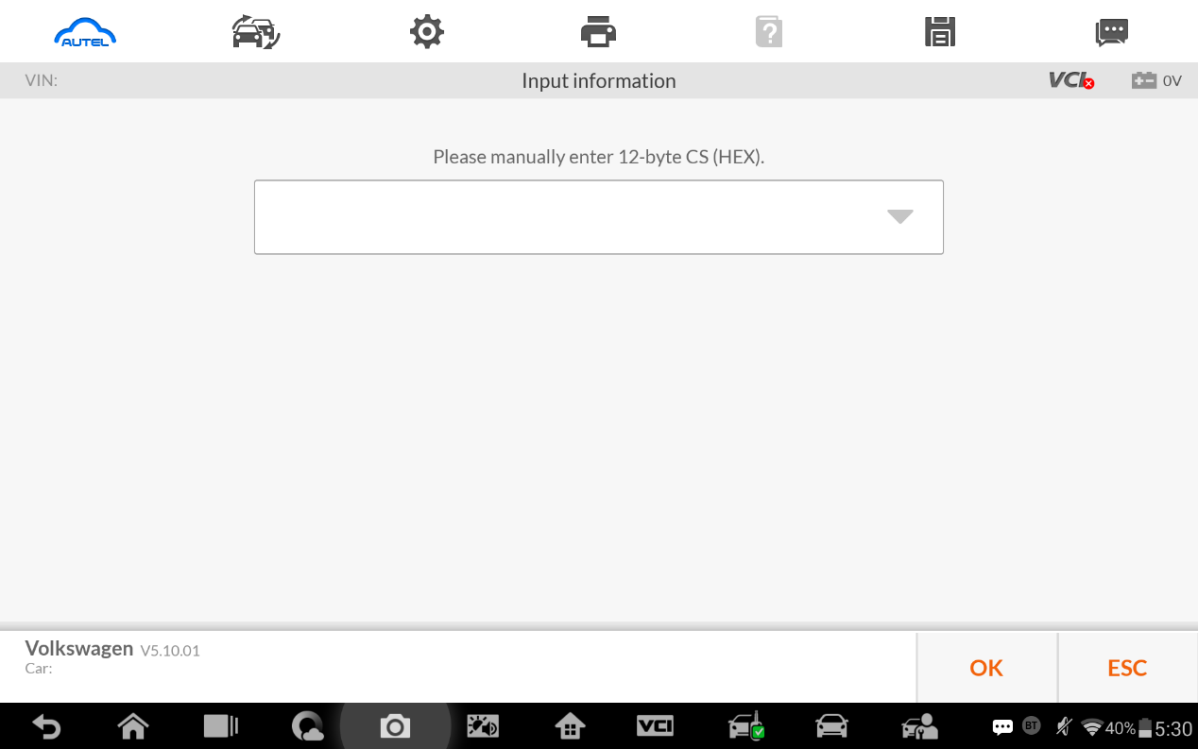

Key learning input pincode and cs code interface. 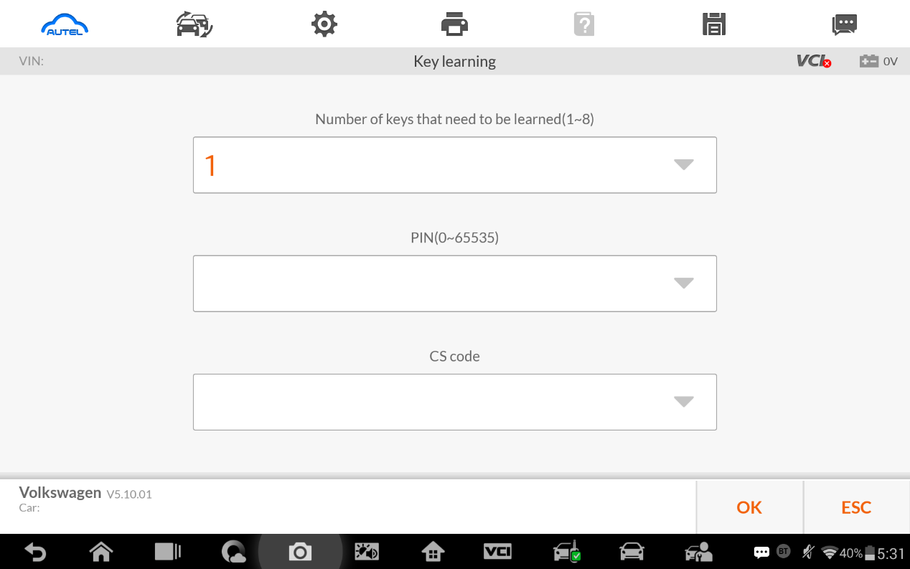

- Immo iv+MQB key programming
Make dealer key:
Expert Selection>IMMO 4+MQB key >Generate dealer key
Key learning:
Expert Selection> IMMO 4+MQB key >Key learning

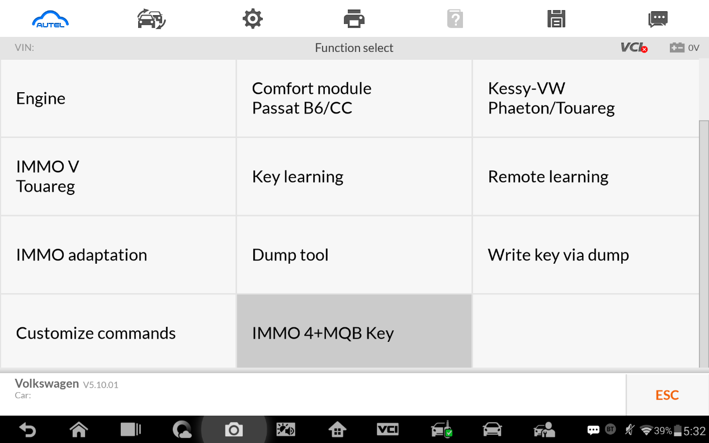

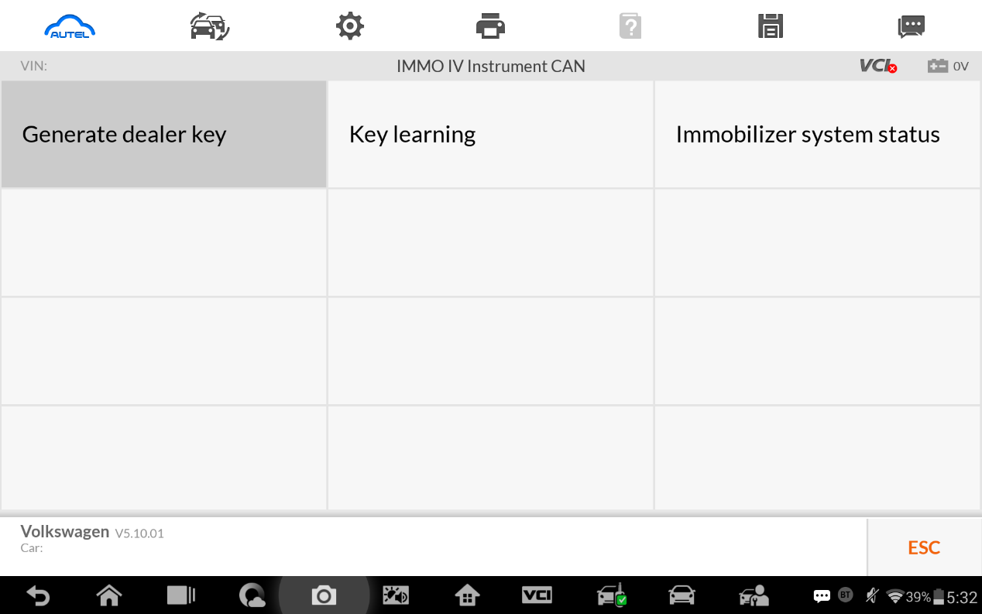

IMMO IV+MQB make dealer key input cs code interface.
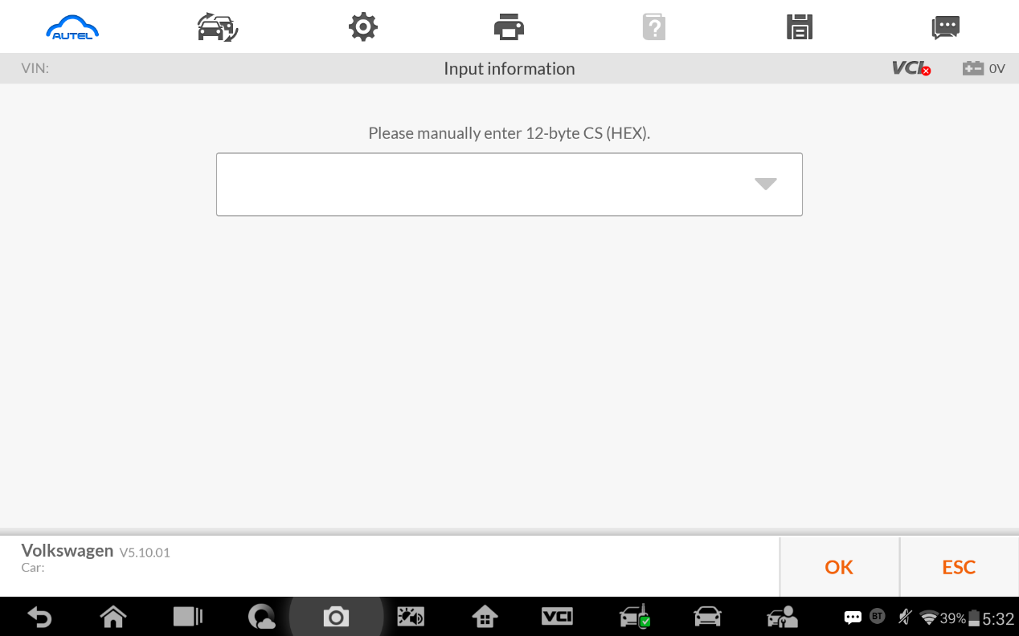

IMMO IV+MQB Key learning interface.
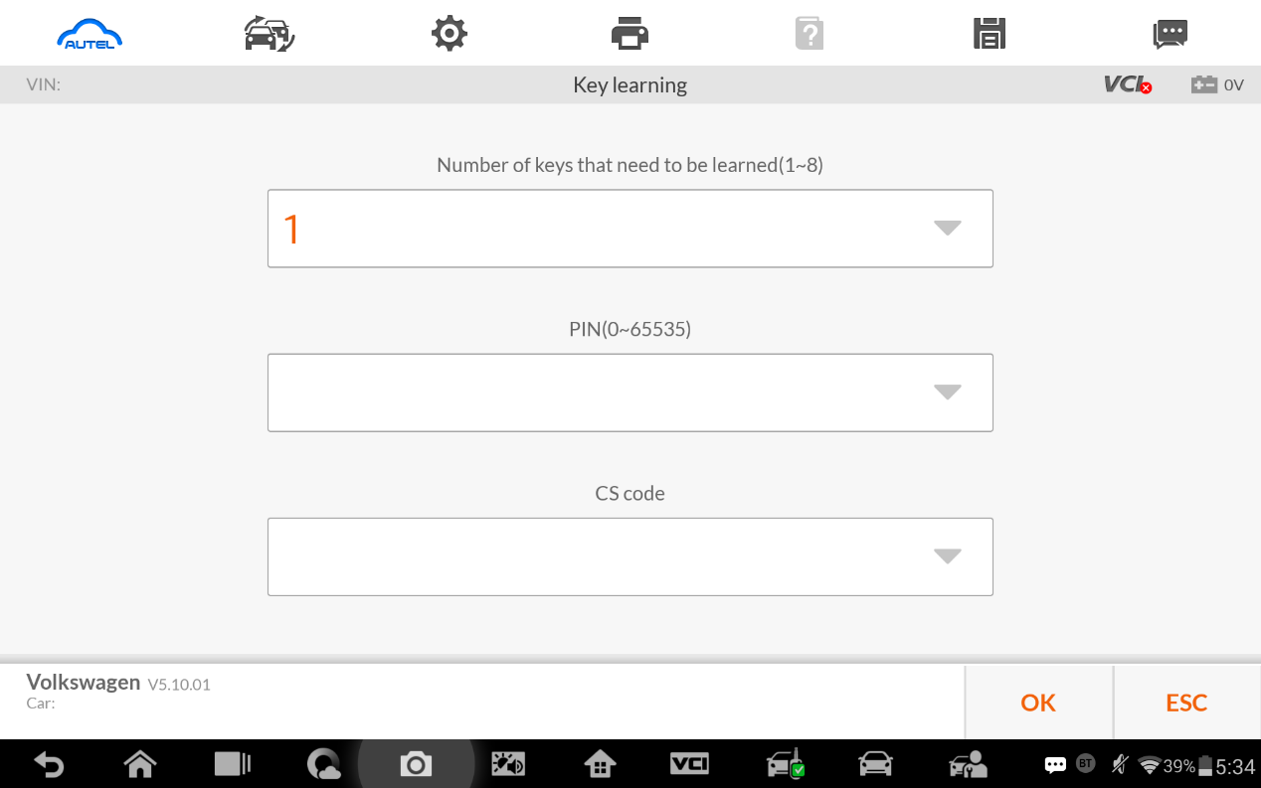

- MQB key programming
Menu Path
Expert Selection>Instrument MQB >VDO NEC 35XX>Make dealer key
Expert Selection>Instrument MQB >VDO NEC 35XX>Key learning

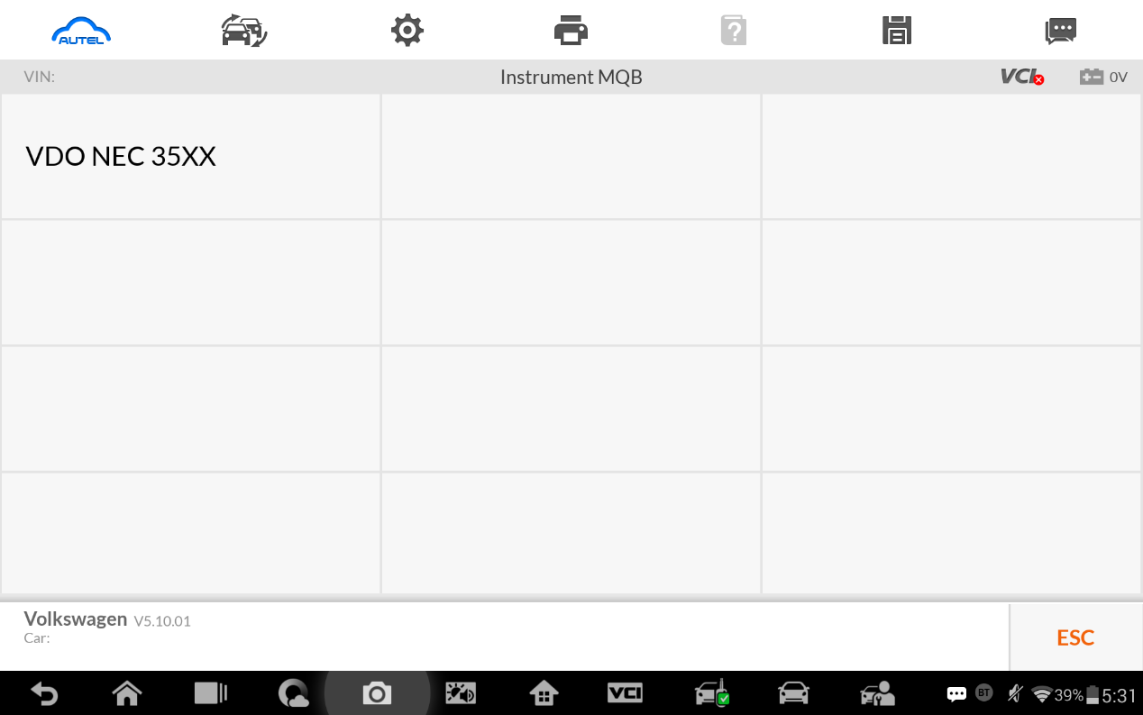

MQB make dealer key input CS code interface.
Without original key then has to input the 32 digits sync data.
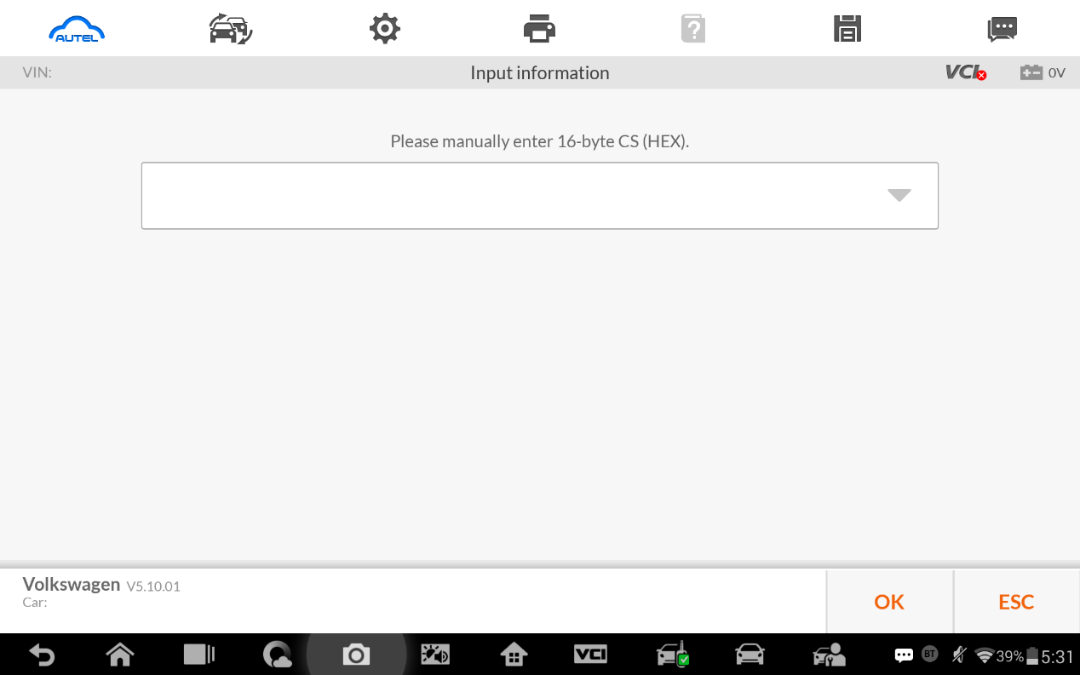
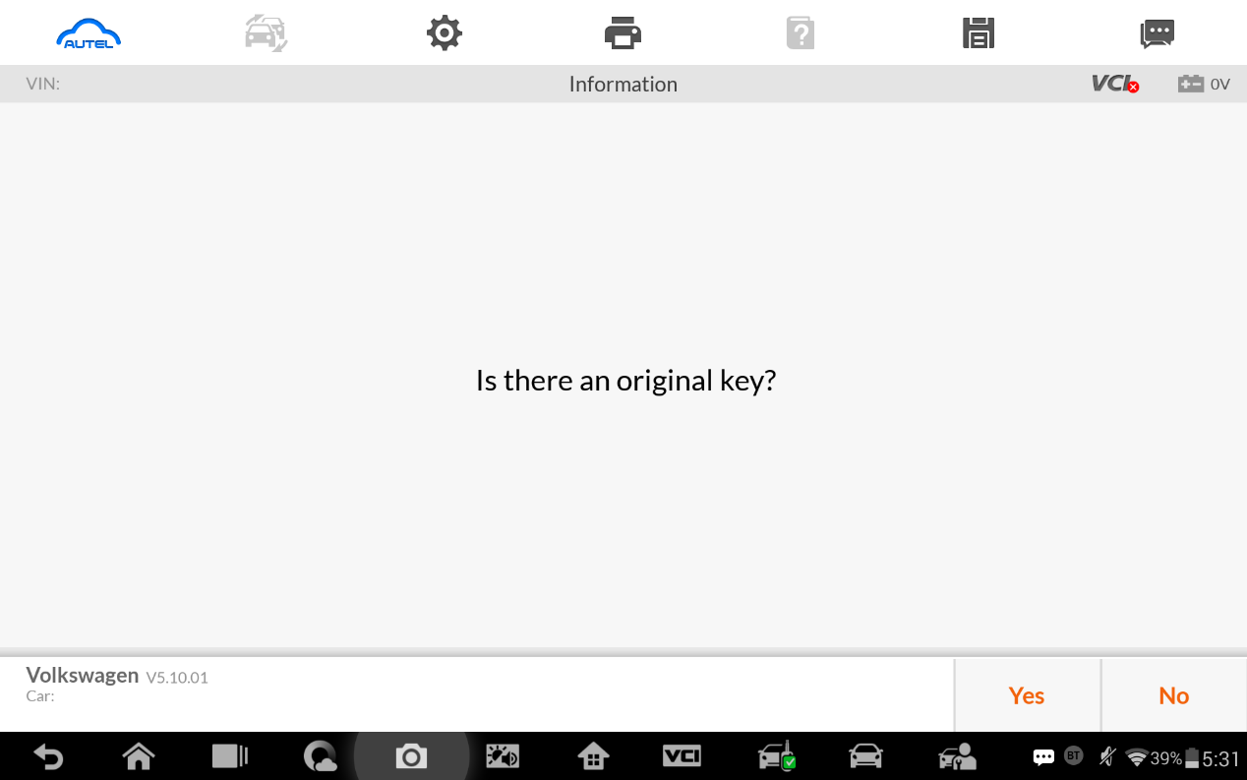

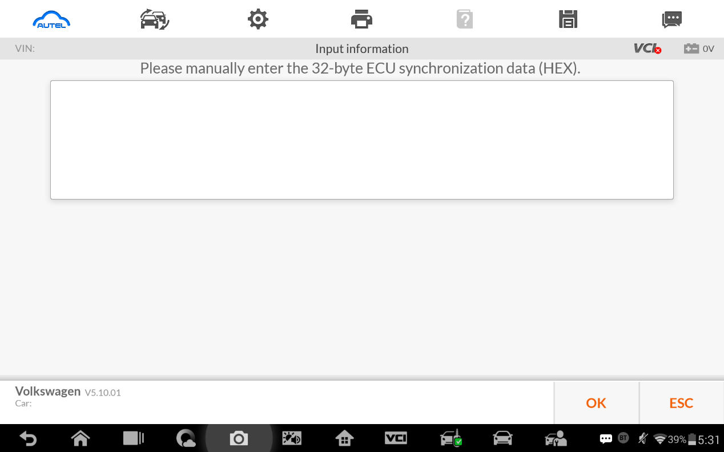

MQB key learning input CS code interface.
